EXPERIMENT 1A:

# Import necessary libraries

import numpy as np

import pandas as pd

from sklearn.datasets import load_iris

from sklearn.model_selection import train_test_split

from sklearn.ensemble import RandomForestClassifier

from sklearn.metrics import confusion_matrix

import matplotlib.pyplot as plt

import seaborn as sns

# Load the Iris dataset

iris = load_iris()

X = iris.data

y = iris.target

# Split the data into training and testing sets

X_train, X_test, y_train, y_test = train_test_split(X, y, test_size=0.2, random_state=42)

# Create and train a Random Forest classifier

model = RandomForestClassifier(random_state=42)

model.fit(X_train, y_train)

# Make predictions on the test set

y_pred = model.predict(X_test)

# Generate the confusion matrix

cm = confusion_matrix(y_test, y_pred)

# Plot the confusion matrix

plt.figure(figsize=(8, 6))

sns.heatmap(cm, annot=True, cmap='Blues', fmt='d', xticklabels=iris.target_names, yticklabels=iris.target_names)

plt.xlabel('Predicted Labels')

plt.ylabel('Actual Labels')

plt.title('Confusion Matrix')

plt.show()

OUTPUT:

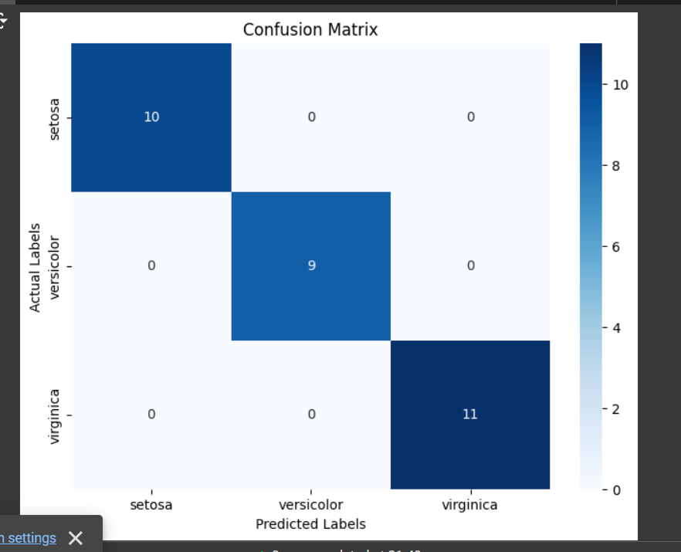

EXPERIMENT 1B:

# Import necessary libraries

import numpy as np

import pandas as pd

from sklearn.datasets import load_breast_cancer

from sklearn.model_selection import train_test_split

from sklearn.linear_model import LogisticRegression

from sklearn.metrics import confusion_matrix, ConfusionMatrixDisplay

import matplotlib.pyplot as plt

import seaborn as sns

# Load the Breast Cancer dataset

data = load_breast_cancer()

X = data.data

y = data.target

# Split the data into training and testing sets

X_train, X_test, y_train, y_test = train_test_split(X, y, test_size=0.2, random_state=42)

# Create and train a Logistic Regression model

model = LogisticRegression(max_iter=10000)

model.fit(X_train, y_train)

# Make predictions on the test set

y_pred = model.predict(X_test)

# Generate the confusion matrix

cm = confusion_matrix(y_test, y_pred)

# Plot the confusion matrix

plt.figure(figsize=(8, 6))

sns.heatmap(cm, annot=True, cmap='Blues', fmt='d', xticklabels=data.target_names, yticklabels=data.target_names)

plt.xlabel('Predicted Labels')

plt.ylabel('Actual Labels')

plt.title('Confusion Matrix')

plt.show()

OUTPUT;

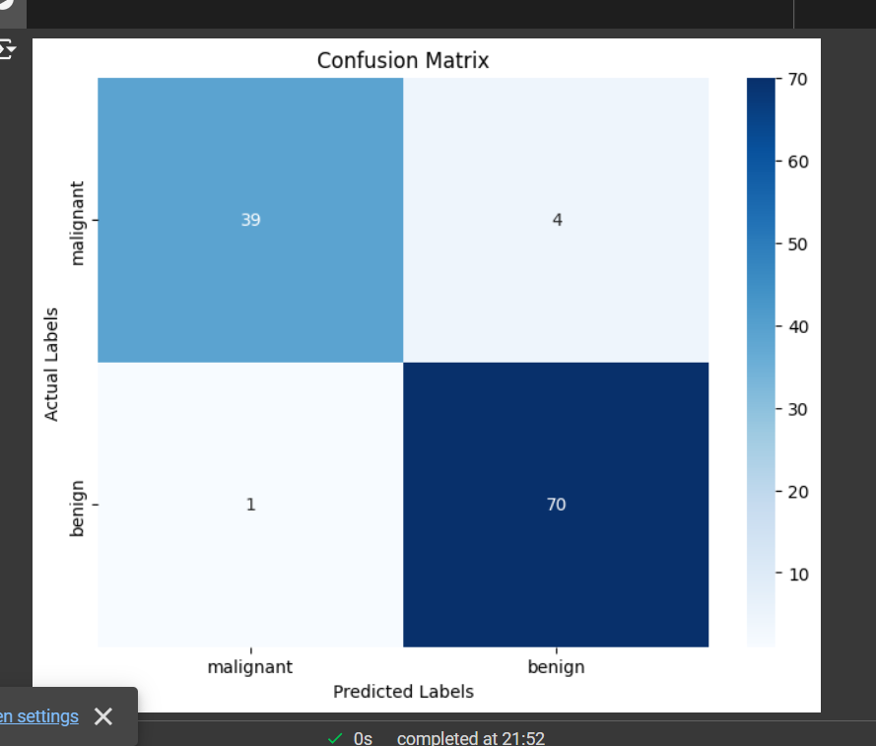

EXPERIMENT 2::

# Import necessary libraries

import numpy as np

import pandas as pd

from sklearn.datasets import load_iris

from sklearn.model_selection import train_test_split

from sklearn.ensemble import RandomForestClassifier

from sklearn.metrics import confusion_matrix, ConfusionMatrixDisplay

import matplotlib.pyplot as plt

import seaborn as sns

# Load the Iris dataset

iris = load_iris()

X = iris.data

y = iris.target

# Split the data into training and testing sets

X_train, X_test, y_train, y_test = train_test_split(X, y, test_size=0.2, random_state=42)

# Create and train a Random Forest classifier

model = RandomForestClassifier(random_state=42)

model.fit(X_train, y_train)

# Make predictions on the test set

y_pred = model.predict(X_test)

# Generate the confusion matrix

cm = confusion_matrix(y_test, y_pred)

# Plot the confusion matrix

plt.figure(figsize=(8, 6))

sns.heatmap(cm, annot=True, cmap='Blues', fmt='d', xticklabels=iris.target_names, yticklabels=iris.target_names)

plt.xlabel('Predicted Labels')

plt.ylabel('Actual Labels')

plt.title('Confusion Matrix')

plt.show()

# Print the confusion matrix for further verification

print("Confusion Matrix:\n", cm)

OUTPUT:

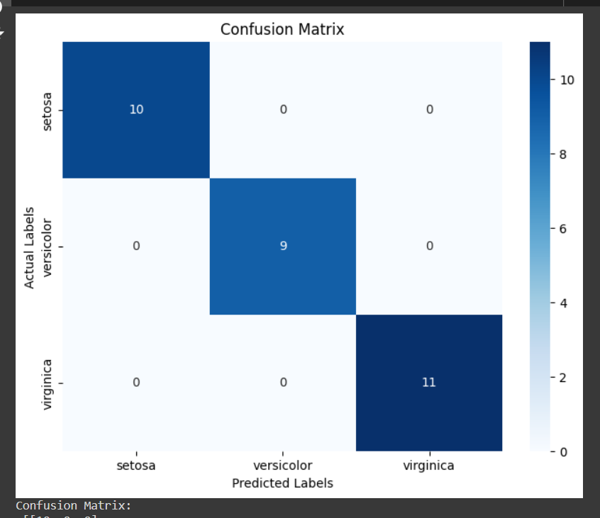

EXPERIMENT 3::

# Import necessary libraries

import numpy as np

import pandas as pd

from sklearn.datasets import load_iris

from sklearn.model_selection import train_test_split

from sklearn.ensemble import RandomForestClassifier

from sklearn.metrics import accuracy_score

# Load the Iris dataset

iris = load_iris()

X = iris.data

y = iris.target

# Split the data into training and testing sets

X_train, X_test, y_train, y_test = train_test_split(X, y, test_size=0.2, random_state=42)

# Create and train a Random Forest classifier

model = RandomForestClassifier(random_state=42)

model.fit(X_train, y_train)

# Make predictions on the training set

y_train_pred = model.predict(X_train)

# Make predictions on the test set

y_test_pred = model.predict(X_test)

# Evaluate the model's accuracy on the training set

train_accuracy = accuracy_score(y_train, y_train_pred)

# Evaluate the model's accuracy on the test set

test_accuracy = accuracy_score(y_test, y_test_pred)

# Print the accuracies to check for overfitting

print(f"Training Accuracy: {train_accuracy}")

print(f"Testing Accuracy: {test_accuracy}")

OUTPUT:

Training Accuracy: 1.0

Testing Accuracy: 1.0